Ethan Allen Sliding Shine

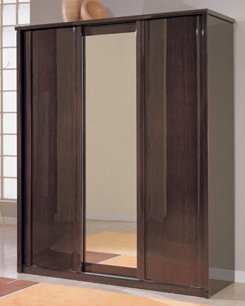

|  |
| --- |
| **DESCRIPTION** |
| Ethan Allan Interior designing has introduced a very detailed extra glossy embedded cupboard with a sleek mirror. The cupboard has a nice feel with smooth surface and the brown color gives it a natural look which enables it to give a relaxing feeling. It will give your house a complete different look and sliding doors enable you to handle the cupboard by applying less force. |

|  |  |  |
| --- | --- | --- |
| **Price** | **1150$** | |
| **Dimensions** | **H** x **W** x **L** | **75in x 22in x 45in** |
| **Features** | **The sliding doors with six build in compartments gives you a lot of space to insert different sizes of goods.** | |
| **Finished** | **Shine Reflector Polish** | |
| **Available in** | **Dark Brown Only** | |